Experiment -2
NAME: SHOBBIKA T ROLL NO:240701502

Design a UI where users recall visual elements (e.g., icons or text chunks). Evaluate the effect of chunking on user memory.

FRAME 1: INSTRUCTION PAGE: Chunking Analysis of the Instruction Page

- The instruction page for the pattern recognition memory game uses chunking effectively by breaking complex recall into simple steps.
- It features a 5x5 grid with colored cells (light green for correct selections, dark for unselected, etc.), clear directives like "Remember the pattern - white boxes," and a prominent "START" button.
- Visual aids such as a timer bar and side panels with checkmarks guide focus, reducing overload while building anticipation for the 4-second observation phase
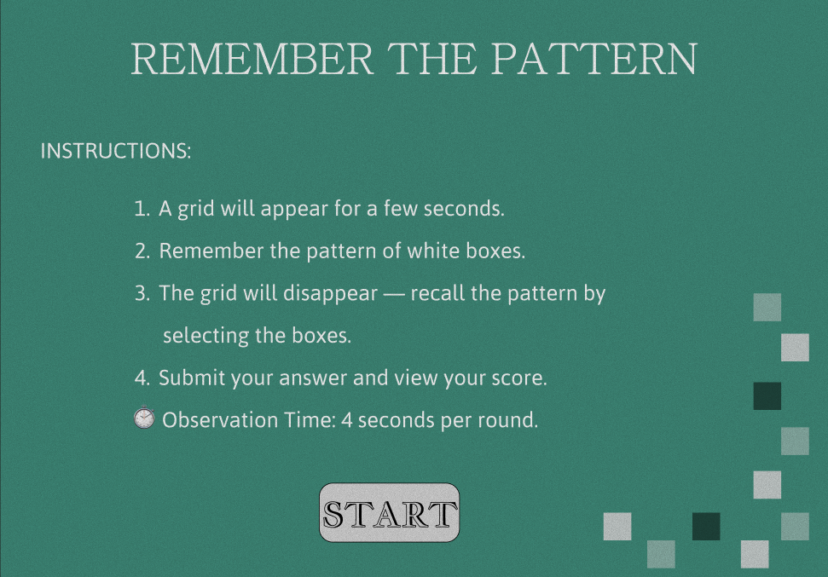

FRAME 2: CHUNKING PHASE: Analysis of the Memory Recall Task - Chunking Phase Screen

- This screen shows the core memorization step where users observe a 5x5 grid pattern of white and black squares for given seconds (progress bar tracks time).
- Chunking occurs naturally by grouping white squares into spatial patterns—users mentally cluster adjacent whites (e.g., top row has two whites) or diagonals for easier retention.
- The green background and subtle borders emphasize the grid without distraction, training quick pattern encoding before recall.​
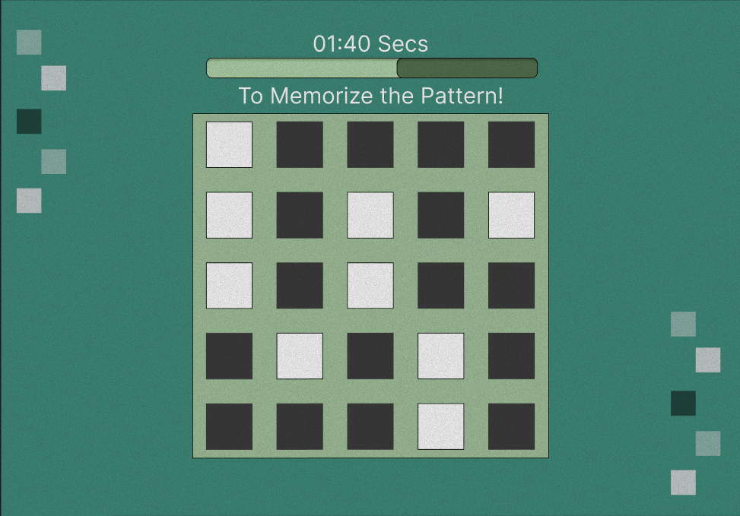

FRAME 3: RECALL PHASE: Analysis of the Memory Recall Task - Selection Phase
- In the recall phase, users face a blank 5x5 grid (all dark squares initially) to select remembered white positions, as hinted by "Recognize the pattern 2/9."
- Chunking aids here by recalling groups: for instance, whites in positions like row 1 columns 2-3, or isolated ones.
- The "Done!" button submits choices, testing if users chunked spatial relations over individual cells, with side indicators (gray/white/dark squares) possibly previewing options.​
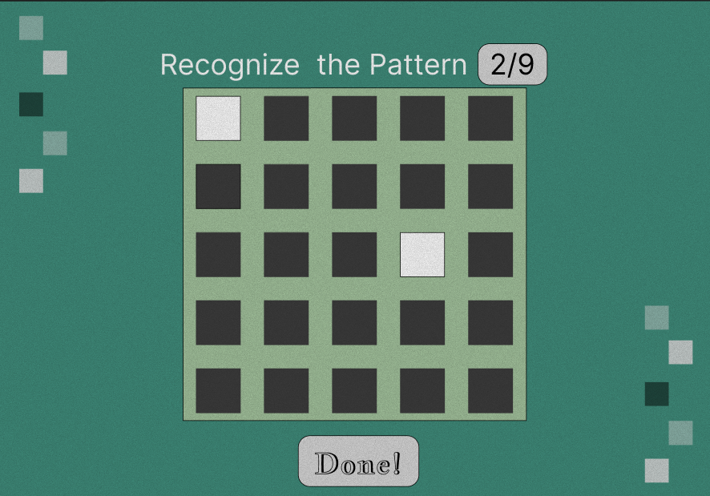

Results Feedback Analysis
- The results screen displays a completed grid with checkmarks (✓) for correct whites, an X for the single miss, and score "8/9" on a green-themed board.
- Chunking shines in feedback: correct clusters are light green, the error in maroon, reinforcing pattern groups visually.
- Options like retry are implied, motivating improvement through instant, grouped error highlighting rather than isolated critiques
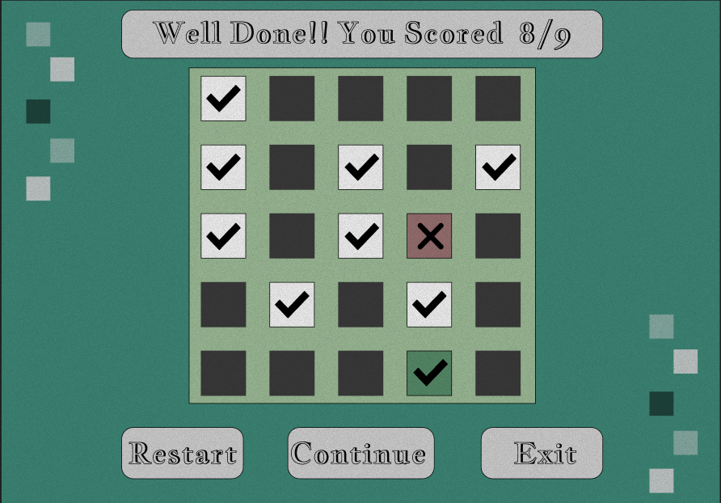
Cognitive & UX Benefits :
- Instant feedback helps users track their memory performance.
- Multiple options (Continue, Restart, Exit) give users control over their learning experience.
- Visual & gamified elements make the task engaging and less stressful.
Prototype link:
https://www.figma.com/design/JLMWBzeQ58anAAvJ5pvo4c/UID-EXP--2?node-id=0-1&t=ugVOPAykLE6kRzvE-1

